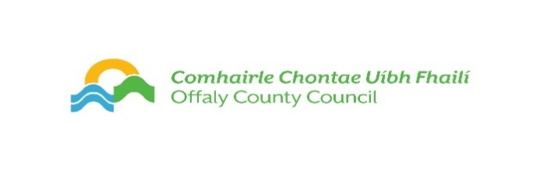

Offaly County Council - Arts Act Grants 2024
Guidelines

Please read carefully to check requirements and eligibility.

THIS IS AN ONLINE APPLICATION PROCESS
CLOSING DATE MONDAY 22 JANUARY 2024 AT 3PM

Offaly County Council assistance under the Arts Act Grant Scheme
Under the Arts Acts Grant Scheme assistance is provided to support a range of arts activity and practice within the community context such as workshops, a project, presentation or event which, in the opinion of the Council, would stimulate public interest in the arts, promote the knowledge, appreciation and practice of the arts, assist in improving the standards of the arts. The Arts Act 2003, defines the “arts” as music, literature, film, video, community arts, drama, dance, visual arts, architecture, and applied arts (the study of arts)

Eligibility
- Voluntary, amateur community organisations participating in arts activity or arts groups who are proposing arts projects within the community. Applications can be made for on-line or physical programming or a combination of both
- Schools may apply, however projects are not for the purpose of supplementing the curriculum, rather projects should be additional and provide alternative art experiences for the students.
- Applicants should be based in County Offaly and undertake an arts project/event within Offaly.
- If engaging a professional artist, applications must show that the organisation and the artist have planned a project and artist CV with examples of work are required.
- Approved projects should take place after approval and before the third week of November of the same year.
- Organisations working with children are required to have the relevant Child Safeguarding Policies and Certificates in place.
- All organisations are required to have a Tax Clearance number and access number
- Only one project per group/organisation.
- Organisation applicants are required be registered with Offaly Public Participation Network (PPN). To do so please email ppn@offalycoco.ie
Ineligible
- Festivals (contact arts@offalycoco.ie for Festival Arts Grants)
- Parades
- Website development & maintenance
- Franchise projects or commercially viable and home craft projects.
- Capital equipment/costs (including instruments, Laptops, projectors, phones etc.)
- Heritage projects that do not involve an artistic outcome
- On-going revenue costs
- Events competitive in nature
- Individual Artists- Training, development of own work (contact arts@offalycoco.ie for artists grants)

Submitting Application: (Closing Date Monday 22nd January 2024 @ 3pm)
THIS IS AN ONLINE APPLICATION ONLY
Follow this link to apply.
https://submit.link/29h
FILLING IN THE FORM – PLEASE NOTE THE FOLLOWING TIPS
Allow yourself plenty of time to fill out the form it can be saved as you go along but before you start it may help to note the following and organise documents (if applicable to project):
- Applications are to be submitted by this online form only. No hardcopy or email applications. Please read eligibility and criteria guidelines. Late applications will be ineligible
- We cannot open Google Drive or Dropbox links etc so please do not include this in any of your documents that you upload
You will need:
- Proposal, clear budget
- Participant numbers
- Professional Artists CV (If contracting an artist)
- Child Safeguarding Statement (if working with children)
- Organisations Constitution
- Quotations
- Tax Clearance number and reference number
IMPORTANT: You cannot submit the form and you will not get verification of submitting the application until all 'required' parts of the form are filled in or uploaded. Ensure you have an email verifying submission.
Funding Criteria
The Arts Act Grants funds 70% of the total project cost up to a maximum of the award given. Groups must demonstrate a financial and/or in-kind contribution to the project. A limited number of grants will be awarded. You should show on the budget how your contribution will be funded. The average grant is between €400 - €800, exceptional projects may be funded up to a maximum of €2,000.

- Priority will be given to art projects that:
- Are innovative and ambitious
- Produce maximum community impact and reach
- Provide quality and professional art experiences to the intended participants
- Make best use of public money (ensure the submission of a high quality, complete application with fully prepared budget)

Applications for funding for arts events and activities should not be undertaken without great thought to the above goals.

A panel nominated by Offaly County Council will make the recommendations to the Elected Members of the Council. Funding recommendations will be made to members of Offaly County Council for final approval.

